One day workshop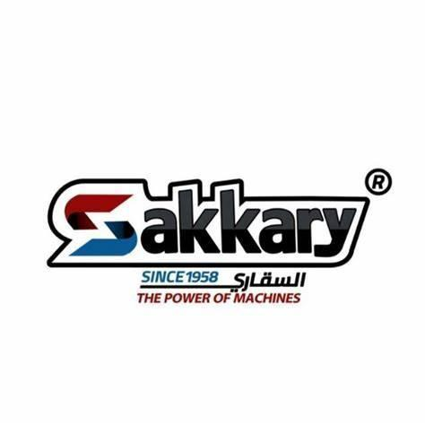

**February 15th**

Document Status: **Draft** | In Review | Approved

**Executive Summary:**Our plan is to build a new workshop that will provide a new service for the normal BMW users, benefiting from the opportunity of low cost material availability,and market our new service to that targeted customer base

| **Project Goal** |
| --- |
| * Al-Sakkary Motors will complete the construction and setup of a new workshop located at 20 Hamooda Street, Hdayek Maadi, Cairo. The workshop will be equipped with all necessary tools and equipment, capable of servicing and completing repairs on three cars simultaneously. We will ensure that each car is fixed within one day of arrival, and the workshop will be fully operational by the end of 2025. * Make a new deal with one of the available material companies to be used in the new workshop, the deal should be done by the end of June 2025. * recruit 2 maintenance teams each team consists of 2 engineers and three mechanics,recruitment phase should take 2 months.   With the aid of the old teams and in 3 months this team will get a proper training and will be able to work independently by the end of the year. |

| **Deliverables** |
| --- |
| 1. WORKSHOP BUILDING (VENDOR CONTRACT) |
| 1. RECRUIT 2 TECHNICAL TEAMS |
| 1. MAKE A CONTRACT WITH THE MATERIAL COMPANY(POWER PARTS) |
| 1. BUY THE NEW EQUIPMENT |

| **Business Case / Background** |
| --- |
| **Why are we doing this?**   * Lately because of inflation some body parts are hard to provide , that causes the company to have some issues with some customers, the customers are dissatisfied from late delivery, and unavailability of some parts. * While there is a opportunity to add new customer base that with our capability to provide them with a service that will also may benefits our existing customer |

| **Benefits, Costs, and Budget** |
| --- |
| **Benefits:**   * Add new customer base * Increase brand awareness * Offer alternative solution for the car parts   **Costs:**   * Facility Costs * Equipment Costs * Licensing and Certifications * Recruitments and training   **Budget needed:**   * $500,000 dollars |

| **Scope and Exclusion** |
| --- |
| **In-Scope:**   * Workshop building, * Recruitment, * training * Material providing   **Out-of-Scope:**   * Old workshop development * Pricing the services * Process development |

| **Project Team** |
| --- |
| **Project Sponsor:** Mr. Fawaz CEO  **Project Lead:** Omar Sakkary  -Mohamed Amin Khafagy, -Yasser Hassan -Ahmed Moftah  **Project Team:**Product manager-Operation manager-Mechanical department manager-Electrical department manager-Hr manager-Marketing manager-Finance manager-Production team leader-Sales manager -HR team leader-Marketing team leader  **Additional Stakeholders:** Mr. Mohamed Al-sakkary (owner),Mrs. Hwaida Al-sakkary, |

| **Measuring Success** |
| --- |
| **What is acceptable:**   1. Reach with this service to 200 customer per month of the BMW users in 2026 2. Make net profit 50,000 dollars per month |